Prince William 4-H

Project Record – Ages 13-18

Name:
Street Address:
City: State: VA Zip Code:
Telephone: Email:
Birthdate (month/date/year): Age: Grade:
Years in 4-H (including current year): Current 4-H Year:

 About Your 4-H Project
Name of 4-H Club:
Name of 4-H Project:
Number of Years Worked on this Project:
Check One: ☐ Project is Ongoing ☐ Project is Complete
I have personally prepared this report and believe it to be correct:
Signature of 4-H Member: Date:

Approval of this 4-H Project Record
We have reviewed this 4-H Project Record and believe it to be correct:
Signature of Parent/Guardian: Date:
Printed Name of Parent/Guardian:
Signature of 4-H Club Leader: Date:
Printed Name of 4-H Club Leader:

My 4-H Project Goals
What are your goals in 4-H this year? Share things you want to do or achieve. Hint: think of your projects and what you hope to learn or accomplish. This section should be filled out at the beginning of the 4-H year.

Did you achieve your goals? How? Reflect on the past year and how you did with your goals. This section should be filled out at the end of the 4-H year.

My 4-H Project Activities
List your activities and efforts towards your project goals for this year, such as presentations during the club business meeting, committee meetings or reports, etc.

Date | Type of Activity | Purpose

Number of business meetings your club held during this year:
Number of meetings you were present at:

Targeting Life Skills
In this section, please use the Life Skills Wheel to write one to two sentences responding to each of the four questions below. The Life Skills Wheel is divided into four sections: Head, Heart, Hands, and Health. Please choose one skill from each section that your 4-H project work has helped you develop or improve.

Life Skills Wheel
HEAD
- Managing: goal setting, planning/organizing, wise use of resources, keeping records, resiliency
- Thinking: learning to learn, decision making, problem solving, critical thinking, service learning
HEART
- Relating: communication, cooperation, social skills, conflict resolution, accepting differences
- Caring: concern for others, empathy, sharing, nurturing relationships
HANDS
- Giving: community service volunteering, leadership, responsible citizenship, contribution to group effort
- Working: marketable skills, teamwork, self-motivation
HEALTH
- Living: healthy lifestyle choices, stress management, disease prevention, personal safety
- Being: self-esteem, self-responsibility, character, managing feelings, self-discipline
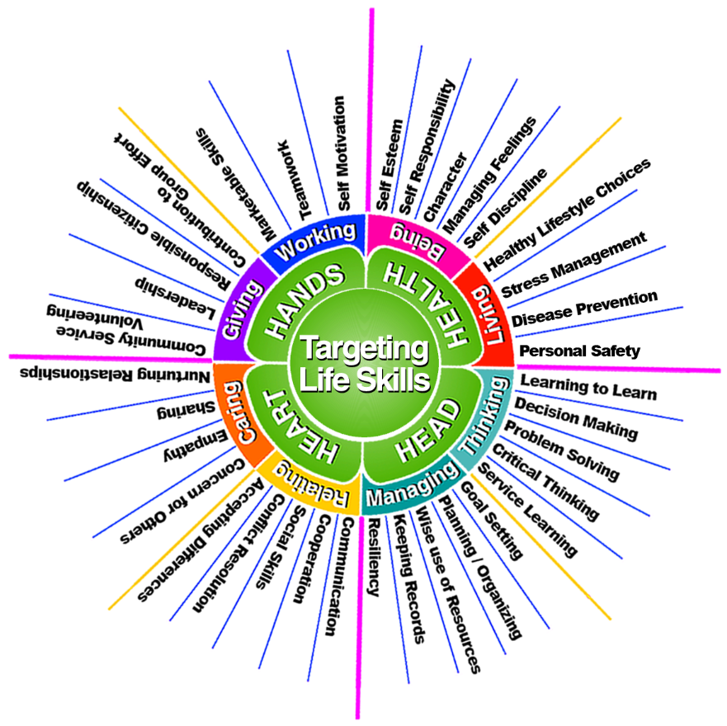

Citation: White, D. J., Williver, S. T., Andress, S., & Stuhr, T. (2020). Dr. Patricia A. Hendricks and the Targeting Life Skills Model: An Oral History. Journal of Extension, 58(6), Article 10. https://doi.org/10.34068/joe.58.06.10

What is one skill in the HEAD section of the Life Skills Wheel that your project work has helped you develop or improve? Why or how has this 4-H project helped you to develop or improve this skill?

What is one skill in the HEART section of the Life Skills Wheel that your project work has helped you develop or improve? Why or how has this 4-H project helped you to develop or improve this skill?
What is one skill in the HANDS section of the Life Skills Wheel that your project work has helped you develop or improve? Why or how has this 4-H project helped you to develop or improve this skill?

What is one skill in the HEALTH section of the Life Skills Wheel that your project work has helped you develop or improve? Why or how has this 4-H project helped you to develop or improve this skill?

Community Service
As a teenager, it is important that you begin to contribute to the quality of life in your community. One way to learn more about your project area is to become involved in a community service project to teach and help others. Describe any community service projects you have participated in that are related to your project. Or describe an idea for a community service project related to your project work that you would like to lead.

Documentation: Photos & Work
Please include 5 to 8 items not already included in your project record that show your work in 4-H this year. This includes photos of you with your 4-H clubmates and leaders at county/district/state events, other images showing your work in 4-H, and other examples. Be sure to label and give context to why you decided to add these items. Add additional pages as needed. Place your 4-H Project Book or curriculum used and any additional pages behind this page.

